**Multi-Factor Authentication at SKG**

Once Multi-Factor Authentication is enabled on your email account, you will need to login to [www.office.com](http://www.office.com) with your SKG email and password. When you login, you should be presented with a screen similar to the following:

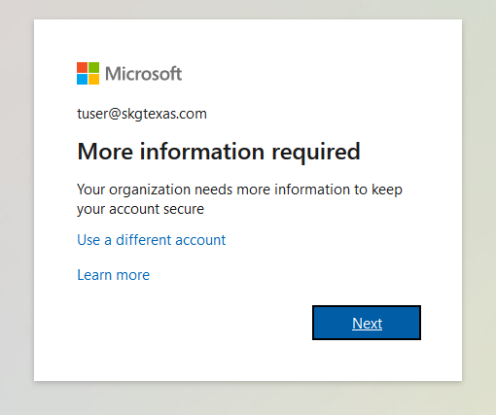

After hitting Next, you will be prompted to choose an authentication mode (METHOD 1 or METHOD 2 below)

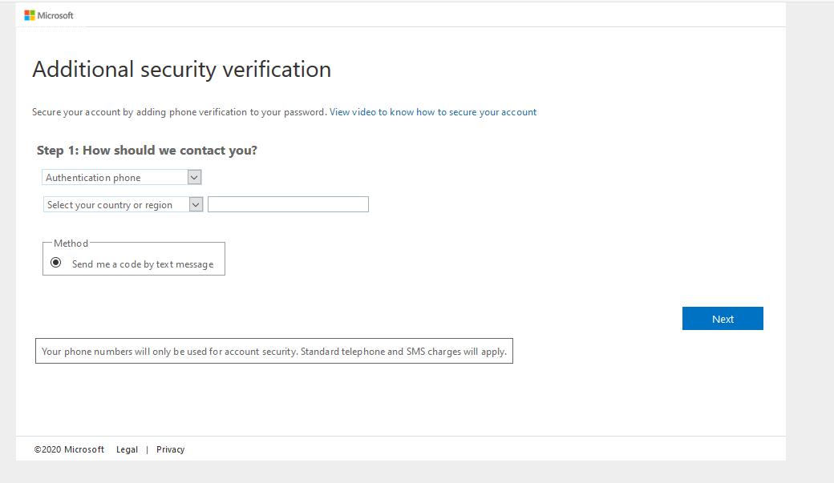

**METHOD 1: If selecting Auth Phone:**  
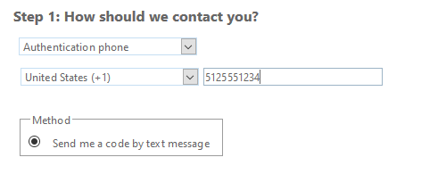

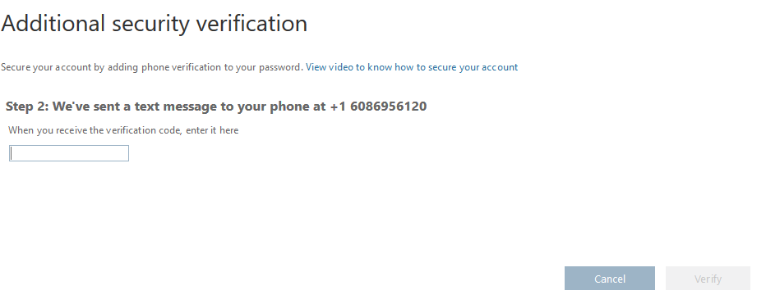

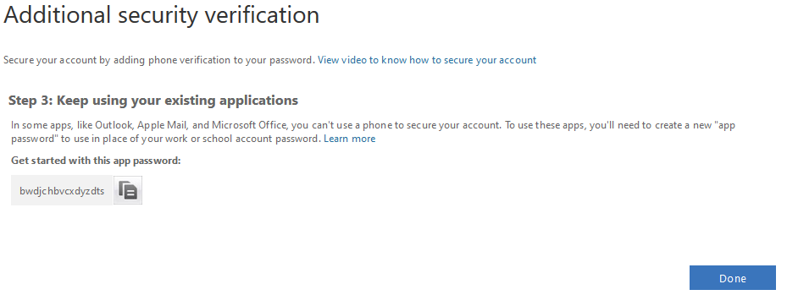

Make note of “app password” in case you need to use it with Microsoft apps that don’t have MFA.

**METHOD 2: If selecting App:**

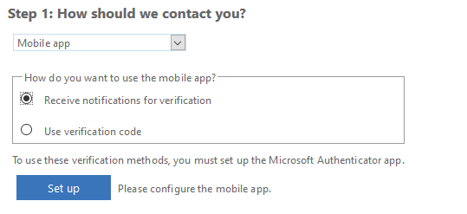

Must download/Install Microsoft Authenticator App on smart phone. Then, after hitting Set up:

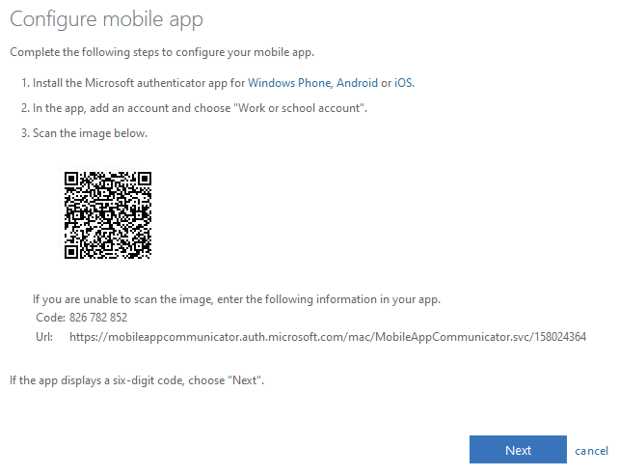

Download Microsoft Authenticator App, launch it, Add Account->Work or School Account. Scan QR code.